***PAAREES PERFUMES***

***DAVIDOFF***

***FOR UNISEX***

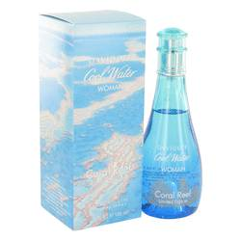

# Cool Water Coral Reef

***Description:***

Cool Water Coral Reef by Davidoff Perfume. Surround yourself with the cool splash of an ocean wave when you wear Cool Water Coral Reef for women. Created in 1988 by the house of Davidoff, the fragrance features the slight floral scent of lily blended with the fleshy sweetness of melon for a refreshingly aromatic scent. Partnered with the National Geographic Society, Davidoff has dedicated his series of cool water reef scents to ocean protection in the areas surrounding the Great Barrier Reef.